18.40: 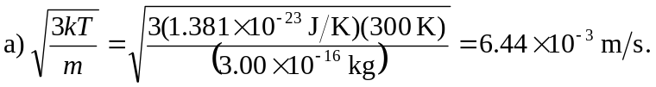 b) If the particle is in thermal equilibrium with its surroundings, its motion will depend only on the surrounding temperature, not the mass of the individual particles.

